Source https://www.getyourguide.com/hobart-l491/bruny-island-safaris-gourmet-food-and-sightseeing-tour-t40903/?partner_id=WJHV1ZE&utm_medium=online_publisher&placement=content-top&deeplink_id=c636cc6d-fdd1-5c64-b227-5a1bc2a0f85f
__________________________________________________________

Bruny Island Gourmet Escape: Wildlife, Lighthouse & Coastal Flavours
__________________________________________________________
★★★★★ 4.7/5 20 reviews

Add to wishlist ♡

__________________________________________________________

10 hours | €200 per person

🏕  Image | 🏕  Image | 🏕  Image | 🏕  Image | 🏕  Image | 🏕  Image

__________________________________________________________
About This Tour
Discover one of Tasmania’s most spectacular islands on a full-day guided adventure combining dramatic coastal landscapes, rare wildlife encounters, and gourmet local tastings. This immersive journey blends nature, history, and culinary indulgence — from freshly shucked oysters on the beach to a guided exploration of the iconic Cape Bruny Lighthouse. Led by passionate local guides, this experience reveals the island’s secrets, stories, and flavours in unforgettable style.
__________________________________________________________
What’s Waiting for You
- Duration: 10 hours
- Group Size: Small groups for a personal experience
- Accommodation: Not included (day tour)
- Languages Available: English
- Private Guide: Not included
- Transportation: Comfortable transport + return ferry included
- Season: Available year-round
- Meeting Point: Pickup from selected Hobart locations (details confirmed after booking)
__________________________________________________________

Check Dates & Availability

Select participants: (Age 99 and younger) - 1 +

Choose date:
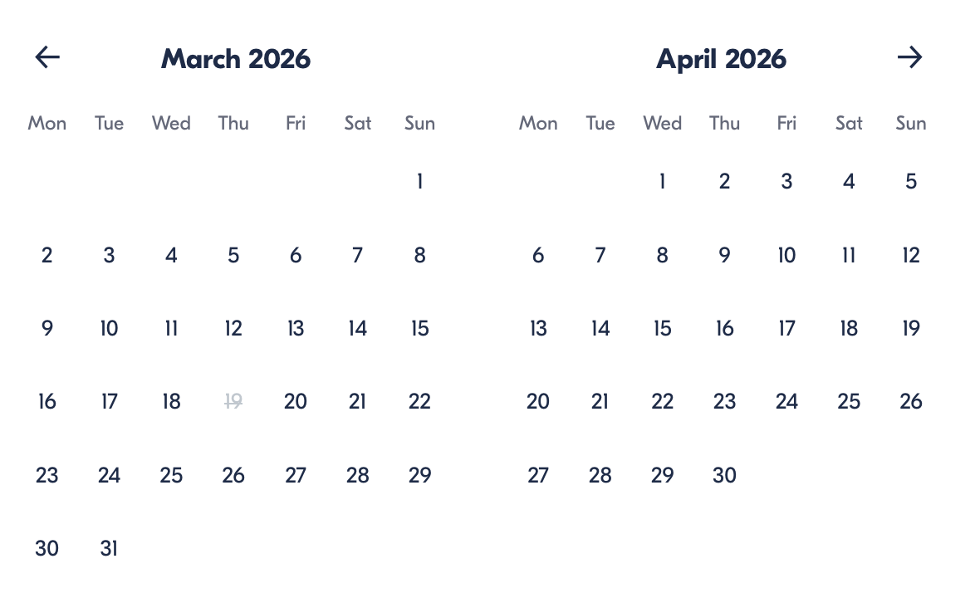

Check Availability

opens:

Participants: 1 March 16, 2026

Bruny Island Gourmet Escape: Wildlife, Lighthouse & Coastal Flavours

- Duration: 10 hours
- Offered in: English
- Starts at: 7:00 AM

Price breakdown: 1 Participant x €200

Total: €200

The total price includes all taxes and fees.

Add to cart Book now

__________________________________________________________
Tour Features
- Taste premium local products, including oysters, cheeses, fudge, chocolate, and honey
- Visit the historic Cape Bruny Lighthouse with exclusive guided access
- Enjoy beachside morning tea featuring artisan island produce
- Spot wildlife such as echidnas, rare wallabies, seabirds, and native reptiles
- Walk through temperate rainforest landscapes with expert interpretation
- Admire iconic viewpoints, including Adventure Bay and The Neck Lookout
- Travel with local guides who share insider stories and island heritage
- Relax with a delicious lunch featuring Tasmanian seafood, beef, or lamb options
__________________________________________________________
Detailed Itinerary
Morning — Scenic Departure & Beach Tastings
Begin with convenient pickup and ferry transfer to Bruny Island. Upon arrival, enjoy beachside morning tea with freshly shucked oysters, local cheese, and wood-fired bread while soaking in ocean views.
Midday — Landscapes & Wildlife Encounters
Travel across the island to panoramic lookouts, coastal cliffs, and rainforest areas. Keep watch for rare wildlife and native flora while your guide shares fascinating ecological and cultural insights.
Afternoon — Lighthouse & Gourmet Lunch
Explore the interior of Cape Bruny Lighthouse and climb its spiral staircase for breathtaking ocean views from 115 metres above sea level. Afterwards, enjoy a locally sourced lunch at the island’s hotel.
Late Afternoon — Artisan Tastings & Return
Visit artisan producers for tastings of chocolate, fudge, cheese, and honey before ferrying back to Hobart with unforgettable memories of Tasmania’s wild island paradise.
__________________________________________________________
Included in Price
- Guided full-day island tour
- Round-trip ferry transport
- Pickup and drop-off at selected locations
- Morning beach tea with local produce
- Lunch at the Bruny Island hotel
- Tastings at local producers
- Cape Bruny Lighthouse guided tour
- Bottled water onboard
- Transport storage for small bags
- All taxes and service fees
__________________________________________________________
Not Included
- National Park entry fee
- Personal purchases
- Additional snacks or drinks not listed
- Travel insurance
__________________________________________________________
Who Should Avoid This Tour
- Children under 2 years old
- Travellers unable to climb stairs (lighthouse access requires steps)
- Guests seare nsitive to long sightseeing days
- Strict vegans have limited tasting options available
- Travellers unable to board ferries
__________________________________________________________
Important Trip Info
- Tour length is approximately 10 hours, including transfers and ferry crossings
- Pickup times are confirmed after booking and may be earlier thanthe start time
- Vegetarian and gluten-free meals are available, but options vary by venue
- Comfortable walking shoes and layered clothing are recommended
- Weather conditions on the island can change quickly — bring sun protection and a jacket
- Large luggage is not permitted on the tour vehicle
- Assistance dogs are allowed; other pets are not
- Most travellers can participate comfortably
__________________________________________________________

Cancellation Policy
For 5 or Fewer Participants:
- More than 2 weeks before arrival: 40% Credit / 60% Refund
- Less than 2 weeks before arrival: 50% Credit / 50% Refund
- Less than 72 hours before arrival: No refund or credit
For 6 or More Participants:
- More than 4 weeks before arrival: 40% Credit / 60% Refund
- Less than 4 weeks before arrival: 80% Credit / 20% Refund
- Less than 2 weeks before arrival: No refund or credit
Weather-Related Cancellations: Fully refunded if the tour cannot operate.
Refund Processing: Within 15 days after tour completion.
__________________________________________________________
What Our Clients Are Saying

Overall rating  4.7/5  ★★★★★  Based on 20 reviews | Review summary  Guide 4.5/5  Transportation 4.6/5  Service 4.7/5  Organisation 4.5/5

Filter  - All traveller types  - Couples  - Group of friends  - Families  By star rating  - All star ratings  - 5 stars  - 4 stars  - 3 stars  - 2 stars  - 1 star | Search reviews (e.g., guide)  Sort by:  - Top picks  - Latest reviews  - Best ratings  - Lowest ratings
__________________________________________________________
★★★★★ Kate T. — Australia
A perfect day of scenery and flavours. The lighthouse visit and tastings were highlights.
★★★★☆ Luca G. — Spain
Beautiful landscapes and wonderful food. The only downside was unpredictable weather.
★★★☆☆ Sophie S. — Germany
Nice tour overall, though I would have liked more variety in tastings.
See more reviews
__________________________________________________________

Meta tags

Page - Bruny Island Gourmet Escape: Wildlife, Lighthouse & Coastal Flavours

Title: Bruny Island Gourmet Escape: Wildlife, Lighthouse & Coastal Flavours | Travellio Global

Description: Explore Bruny Island on a full-day guided adventure featuring wildlife encounters, lighthouse access, gourmet tastings, and stunning coastal scenery.

H1 - Bruny Island Gourmet Escape: Wildlife, Lighthouse & Coastal Flavours
__________________________________________________________

